

\

5CS037-Concepts and Technologies of AI

Final Portfolio Project
Classification Analysis Using Australian Weather Dataset

Module Leader: Siman Giri
Student Name: Saugat Pokharel
College ID: np03cs4a240094
University ID: 2463017

Abstract
This project presents a comprehensive classification analysis of the Australian Rainfall (WeatherAUS) dataset with the objective of predicting next-day rainfall using supervised machine learning techniques. Aligned with the United Nations Sustainable Development Goal 13 (Climate Action), the study explores how data-driven models can support climate adaptation and environmental planning. Extensive exploratory data analysis was conducted to understand seasonal trends, geographic variability, feature correlations, and class imbalance. A Multi-Layer Perceptron (MLP) neural network was developed and evaluated alongside two classical models: Logistic Regression and Decision Tree. Model performance was assessed using accuracy, precision, recall, and F1-score, with particular emphasis on the minority rain class. Hyperparameter tuning using GridSearchCV and feature selection via SelectKBest were applied to enhance robustness and interpretability. Results indicate that the neural network achieved the highest overall performance, while Logistic Regression emerged as the strongest classical model. The findings highlight the predictive importance of humidity, pressure, and temperature variables and demonstrate the value of machine learning in rainfall prediction tasks.
Keywords:
Rainfall Prediction, Classification, Australian Weather Dataset, Machine Learning, Neural Network, Logistic Regression, Decision Tree, Hyperparameter Optimization, Feature Selection, Climate Action

Table of Contents

1. Introduction 1
2. Choosing a Dataset 2
3. Methodology, Results, and Interpretation 3
3.1 Exploratory Data Analysis (EDA) 3
3.2 Neural Network Model for Classification 6
3.3 Primary Machine Learning Models (Two Classical Models) 8
3.4 Hyperparameter Optimization with Cross-Validation 11
3.5 Feature Selection 12
3.6 Final Models and Comparative Analysis 13
4. Conclusion and Reflection 15
4.1 Model Performance 15
4.2 Impact of Methods 15
4.3 Insights and Future Directions 15
5. References 16
6. Appendix 17

List of Tables

Table 1: Neural Network (MLP) Classification Report (Test Set) 6
Table 2: Logistic Regression Classification Report (Test Set) 8
Table 3: Decision Tree Classification Report (Test Set) 9
Table 4: Model Performance Comparison (Logistic Regression vs. Decision Tree) 10
Table 5: Best Hyperparameters (GridSearchCV) 11
Table 6: Cross-Validation F1 Scores After Hyperparameter Tuning 11
Table 7: Best Hyperparameters After Feature Selection 12
Table 8: Optimised Logistic Regression (Test Set Results) 13
Table 9: Optimised Decision Tree (Test Set Results) 13
Table 10: Final Model Comparison Table 14

List of Figures

Figure 1: Probability of Rain by Month (Seasonality) 3
Figure 2: Top 10 Locations with Lowest vs. Highest Rain Probability 4
Figure 3: Distribution of Target Variable (RainTomorrow) 4
Figure 4: Correlation Heatmap of Numerical Features 5
Figure 5: Confusion Matrix Neural Network (MLP) 7
Figure 6: Confusion Matrix for Logistic Regression 8
Figure 7: Confusion Matrix for Decision Tree 9

Introduction
Classification is a fundamental supervised machine learning paradigm where algorithms are trained to categorize input observations according to patterns discovered in past data. It is extensively used in a variety of fields, including environmental science, healthcare, and finance, for tasks like predicting the weather, detecting fraud, and diagnosing illnesses. With the target variable "RainTomorrow," this report presents a thorough classification analysis of the Australian Rainfall (WeatherAUS) dataset to determine whether it will rain the next day. The primary objectives of this analysis are:
- To explore and preprocess the dataset through rigorous exploratory data analysis
- To build and evaluate a Neural Network classifier (Multi-Layer Perceptron) alongside two classical machine learning models Logistic Regression and Decision Tree
- To optimize model performance through hyperparameter tuning using GridSearchCV with cross-validation
- To apply feature selection to reduce dimensionality and improve generalization
- To conduct a comparative analysis to identify the best-performing model.
The dataset is aligned with United Nations Sustainable Development Goal 13: Climate Action, as accurate rainfall prediction supports climate adaptation, disaster preparedness, and sustainable environmental planning. The scope of this report encompasses data preprocessing, model development, hyperparameter optimisation, feature selection, and final model evaluation.

Choosing a Dataset
The dataset selected for this classification analysis is the Australian Rainfall (WeatherAUS) dataset, sourced from Kaggle and originally compiled by the Australian Bureau of Meteorology. It comprises 145,460 daily weather observations across 23 features recorded from multiple locations across Australia. The target variable is "RainTomorrow", a binary categorical feature indicating whether rainfall occurred the following day ("Yes" or "No"). Key predictor features include temperature readings (MinTemp, MaxTemp), humidity levels (Humidity9am, Humidity3pm), atmospheric pressure (Pressure9am, Pressure3pm), wind speed and direction, rainfall amount, and the indicator variable "RainToday".
The dataset contains both numerical (e.g., temperature, pressure) and categorical (e.g., wind direction, location) features suitable for classification modelling. Initial inspection revealed 145,460 rows and 23 columns with class imbalance in the target variable.
This dataset is well-suited for binary classification as the target variable presents a clear two-class prediction problem. Its alignment with UNSDG 13 (Climate Action) is justified, as classifying rainfall events can inform early warning systems, agricultural planning, and climate adaptation strategies.

Methodology, Results, and Interpretation

Exploratory Data Analysis (EDA)
A thorough exploratory data analysis was conducted to understand the structure, quality, and distributional properties of the dataset. Data types were inspected, missing values were quantified, and duplicate records were checked. Columns with excessive missing values (>35%) Sunshine, Evaporation, Cloud9am, and Cloud3pm were dropped. Remaining missing values in numerical columns were imputed with the median, and categorical columns were imputed with the mode. Rows with missing target values were removed. The target variable "RainTomorrow" was encoded as binary (1 = Yes, 0 = No).
No duplicate rows were found in the dataset. After preprocessing, the dataset was clean and ready for modelling. Visual analysis revealed seasonal patterns in rainfall probability, geographic variations, significant class imbalance, and strong correlations among temperature and humidity features.
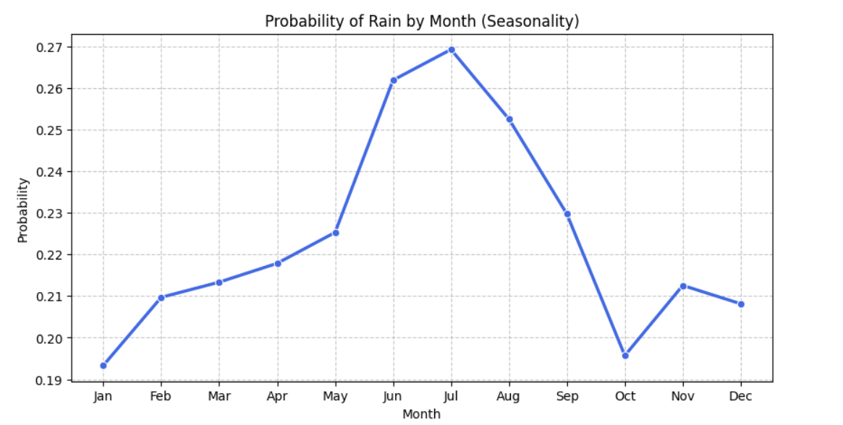
Figure 1: Probability of Rain by Month (Seasonality)

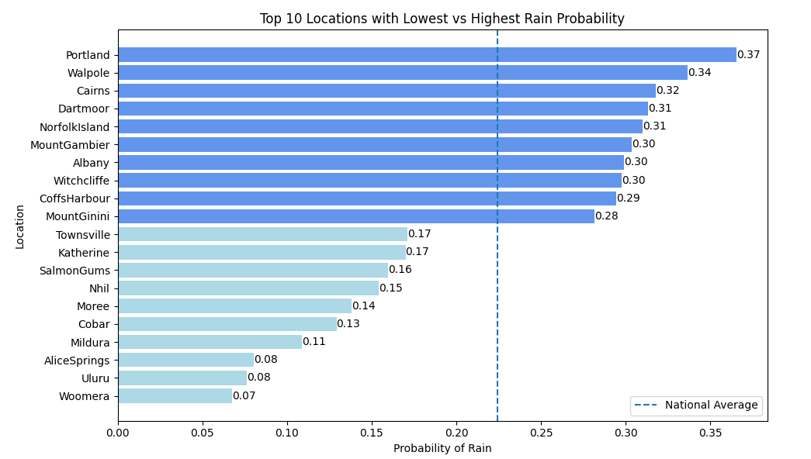
Figure 2: Top 10 Locations with Lowest vs. Highest Rain Probability

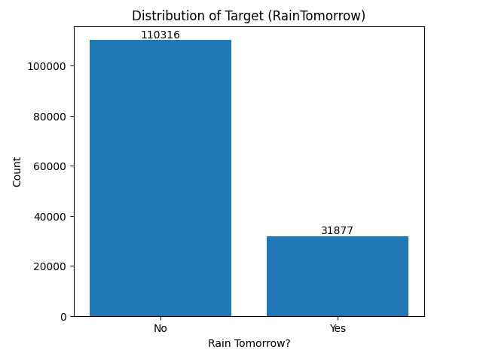
Figure 3: Distribution of Target Variable (RainTomorrow)
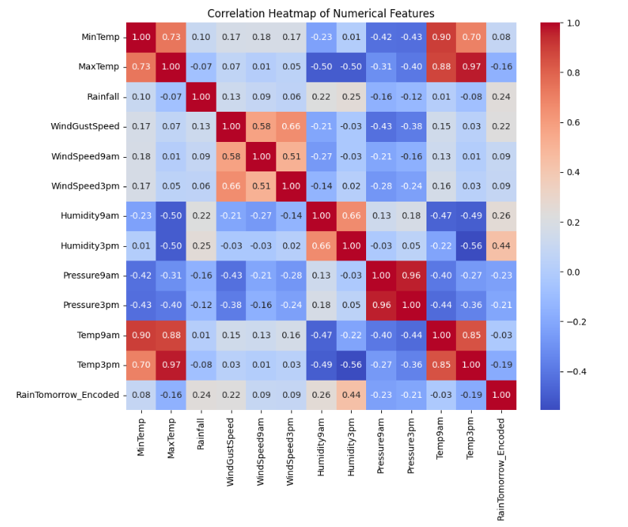
Figure 4: Correlation Heatmap of Numerical Features

The seasonality plot (Figure 1) showed that rainfall probability peaks during winter months (June–August) and declines during summer (December–February), consistent with Australian seasonal patterns. The location analysis (Figure 2) revealed that tropical northern regions exhibit higher rainfall probability, while arid inland locations show the lowest. The target distribution (Figure 3) confirmed significant class imbalance with approximately 22,064 "No" versus 6,375 "Yes" instances in the test set (~3.5:1 ratio). The correlation heatmap (Figure 4) identified strong positive correlations among temperature features and notable negative correlations between humidity and pressure variables, with Humidity3pm showing the strongest association with the target variable.

Neural Network Model for Classification
A Multi-Layer Perceptron (MLP) classifier was implemented using scikit-learn's MLPClassifier. The architecture consisted of two hidden layers with 64 and 32 neurons respectively, employing the Rectified Linear Unit (ReLU) activation function for non-linear transformations. The Adam optimiser was selected for weight optimisation due to its adaptive learning rate properties. The model was trained for 50 iterations (epochs). Prior to training, all features were standardised using StandardScaler to ensure uniform feature scales, which is essential for neural network convergence. The dataset was split into 80% training and 20% test sets with stratified sampling to preserve class distribution.
Class | Precision | Recall | F1-Score
0 (No Rain) | 0.89 | 0.92 | 0.91
1 (Rain) | 0.69 | 0.60 | 0.64
Accuracy |  |  | 0.8501
Macro Avg | 0.79 | 0.76 | 0.77
Weighted Avg | 0.84 | 0.85 | 0.85

Table 1: Neural Network (MLP) Classification Report (Test Set)

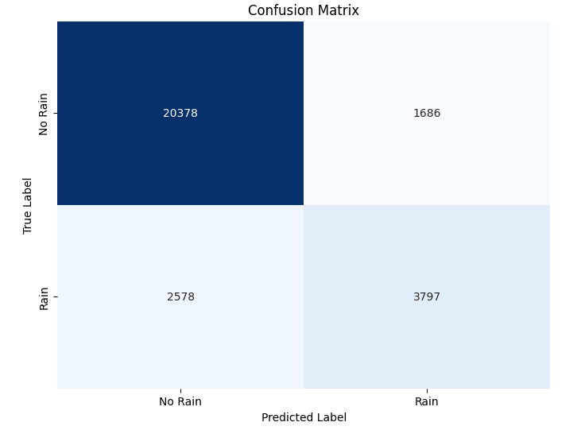
Figure 5: Confusion Matrix Neural Network (MLP)

The MLP achieved a test accuracy of 85.01%, with strong performance on the majority class (No Rain: F1 = 0.91) but lower recall (0.60) for the minority class (Rain). The gap between training accuracy (89.82%) and test accuracy (85.01%) suggests mild overfitting. The F1-score of 0.64 for the Rain class indicates moderate effectiveness in predicting positive rainfall events, which is reasonable given the class imbalance. The model correctly identified 3,797 true rain events but misclassified 2,578 rain events as no rain (false negatives). Overall, the neural network provides a strong baseline for comparison against classical models.

Primary Machine Learning Models (Two Classical Models)
Two classical machine learning models were trained and evaluated: Logistic Regression and Decision Tree Classifier. Both models utilised the same 80/20 stratified train-test split and standardised features as the neural network for consistency. Logistic Regression was implemented with the "liblinear" solver, which is efficient for binary classification. The Decision Tree was initialised with default parameters. Model performance was assessed using accuracy, precision, recall, and F1-score metrics on the test set.
- Logistic Regression
Class | Precision | Recall | F1-Score
0 (No Rain) | 0.87 | 0.95 | 0.91
1 (Rain) | 0.73 | 0.49 | 0.59
Accuracy |  |  | 0.8461

Table 2: Logistic Regression Classification Report (Test Set)

Figure 6: Confusion Matrix for Logistic Regression
- Decision Tree Classifier
Class | Precision | Recall | F1-Score
0 (No Rain) | 0.86 | 0.86 | 0.86
1 (Rain) | 0.52 | 0.53 | 0.53
Accuracy |  |  | 0.7862

Table 3: Decision Tree Classification Report (Test Set)

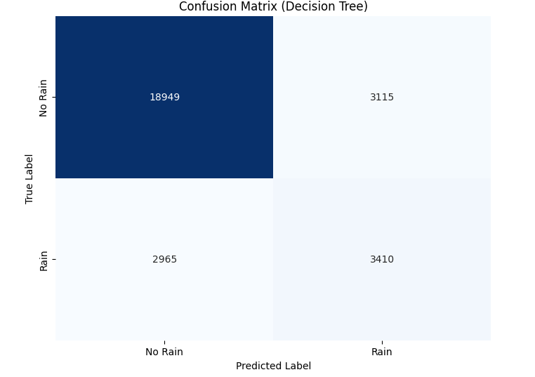
Figure 7: Confusion Matrix for Decision Tree

Metric | Logistic Regression | Decision Tree
Test Accuracy | 0.8461 | 0.7862
Precision (Rain) | 0.73 | 0.52
Recall (Rain) | 0.49 | 0.53
F1-Score (Rain) | 0.59 | 0.53

Table 4: Model Performance Comparison (Logistic Regression vs. Decision Tree)

Logistic Regression outperformed the Decision Tree across most evaluation metrics, achieving approximately 6% higher accuracy (0.8461 vs. 0.7862) and a substantially better F1-score for the minority Rain class (0.59 vs. 0.53). While the Decision Tree exhibited marginally higher recall for rain events (0.53 vs. 0.49), its precision was considerably lower (0.52 vs. 0.73), indicating a higher rate of false positive predictions. Logistic Regression demonstrates stronger generalisation capability, making it the preferred classical model. Both models exhibited lower recall for the Rain class, reflecting the challenge posed by class imbalance in the dataset.

Hyperparameter Optimization with Cross-Validation
Hyperparameter optimization was performed using GridSearchCV with 5-fold cross-validation, optimising for the F1-score metric to directly address the class imbalance challenge. For Logistic Regression, the hyperparameters tuned were: regularisation strength C ∈ {0.01, 0.1, 1, 10, 100}, penalty type (l2), and solvers (liblinear, saga). For the Decision Tree, the tuned hyperparameters were: max_depth ∈ {5, 10, 20, None}, min_samples_split ∈ {2, 10, 20}, and min_samples_leaf ∈ {1, 5, 10}. A total of 50 parameter combinations were evaluated for Logistic Regression and 180 for the Decision Tree.

Model | Best Hyperparameters
Logistic Regression | C = 10, penalty = l2, solver = saga
Decision Tree | max_depth = 10, min_samples_leaf = 1, min_samples_split = 2

Table 5: Best Hyperparameters (GridSearchCV)

Model | Best CV F1-Score
Logistic Regression | 0.5890
Decision Tree | 0.5694

Table 6: Cross-Validation F1 Scores After Hyperparameter Tuning

GridSearchCV identified optimal hyperparameters for both models. Logistic Regression achieved a marginally higher cross-validation F1-score (0.5890) compared to the Decision Tree (0.5694), confirming its relative superiority. The optimal regularisation strength of C = 10 for Logistic Regression indicates that moderate regularisation improved generalisation. For the Decision Tree, a maximum depth of 10 effectively constrained tree growth and mitigated overfitting. Cross-validation ensured that reported scores are robust estimates of out-of-sample performance rather than artefacts of a single train-test split.

Feature Selection
The SelectKBest filter method with ANOVA F-statistic (f_classif) scoring was applied to select the top 15 most statistically significant features. This filter-based technique evaluates each feature's relevance to the target variable independently of the model, making it computationally efficient for high-dimensional datasets. After feature selection, both Logistic Regression and Decision Tree were retrained using GridSearchCV with 5-fold cross-validation on the reduced feature set to identify updated optimal hyperparameters.

Model | Best Hyperparameters | CV F1-Score
Logistic Regression | C = 1, penalty = l2, solver = liblinear | 0.5640
Decision Tree | max_depth = 10, min_samples_leaf = 1, min_samples_split = 20 | 0.5682

Table 7: Best Hyperparameters After Feature Selection

Feature selection reduced input dimensionality from the full feature set to 15 key predictors. Humidity, pressure, and temperature variables dominated the selected features, consistent with EDA findings. The CV F1-scores showed a slight decline compared to full-feature models, suggesting that some removed features contained marginal but useful information. Notably, the Decision Tree slightly outperformed Logistic Regression on the reduced feature set (0.5682 vs. 0.5640), indicating that tree-based models can exploit non-linear relationships even with fewer features. The reduced dimensionality improves interpretability and lowers computational cost.

Final Models and Comparative Analysis
Final models were constructed using the optimal hyperparameters identified through cross-validated GridSearchCV combined with the selected feature subset from SelectKBest. Logistic Regression was rebuilt with C = 1, penalty = l2, and solver = liblinear. The Decision Tree was rebuilt with max_depth = 10, min_samples_leaf = 1, and min_samples_split = 20. Both models were trained on the 15 selected features and evaluated on the held-out test set using accuracy, precision, recall, and F1-score metrics. The final optimized models were evaluated on the test set, and their performance is summarized below.

Class | Precision | Recall | F1-Score
0 (No Rain) | 0.86 | 0.95 | 0.90
1 (Rain) | 0.73 | 0.47 | 0.57
Accuracy |  |  | 0.8419

Table 8: Optimised Logistic Regression (Test Set Results)

Class | Precision | Recall | F1-Score
0 (No Rain) | 0.86 | 0.94 | 0.90
1 (Rain) | 0.71 | 0.47 | 0.57
Accuracy |  |  | 0.8380

Table 9: Optimised Decision Tree (Test Set Results)

Metric | Logistic Regression | Decision Tree
Features | Selected (15) | Selected (15)
CV F1-Score | 0.5640 | 0.5682
Test Accuracy | 0.8419 | 0.8380
Precision (Rain) | 0.7298 | 0.7081
Recall (Rain) | 0.4681 | 0.4722
F1-Score (Rain) | 0.5703 | 0.5665

Table 10: Final Model Comparison Table

Both final models exhibited closely comparable performance on the test set. Logistic Regression achieved marginally higher test accuracy (0.8419 vs. 0.8380) and slightly better precision for the Rain class (0.73 vs. 0.71). The Decision Tree showed marginally superior recall for the Rain class (0.4722 vs. 0.4681), indicating a slight edge in detecting actual rainfall events. The F1-scores for both models were nearly identical (~0.57), confirming equivalent predictive capability on the minority class. Logistic Regression is identified as the best-performing classical model due to its consistently higher accuracy and precision. Compared to the initial Neural Network (MLP), which achieved a test accuracy of 0.8501 and an F1-score of 0.64 for the Rain class, the classical models performed marginally lower, suggesting that the non-linear learning capacity of neural networks provides a measurable advantage for this classification task.

Conclusion and Reflection

Model Performance
This classification analysis demonstrated that all three models Multi-Layer Perceptron, Logistic Regression, and Decision Tree achieved reasonable performance in predicting next-day rainfall in Australia. The Neural Network achieved the highest test accuracy (85.01%) and the best Rain-class F1-score (0.64), followed by Logistic Regression (84.19%, F1 = 0.57) and Decision Tree (83.80%, F1 = 0.57). All models exhibited lower recall for the minority Rain class, reflecting the inherent challenge of predicting rare events in an imbalanced dataset.

Impact of Methods
Hyperparameter optimization via GridSearchCV with 5-fold cross-validation improved model robustness by systematically identifying optimal configurations and providing reliable estimates of generalisation performance. Feature selection using SelectKBest reduced dimensionality from the full feature set to 15 key predictors, enhancing interpretability while maintaining comparable accuracy. The marginal reduction in F1-scores after feature selection confirms that the retained features captured the majority of the predictive signal, validating the effectiveness of the filter-based approach.

Insights and Future Directions
Key insights include the strong predictive importance of humidity, pressure, and temperature features, as well as the seasonal and geographic variation in rainfall probability. Limitations of this study include class imbalance, which adversely affected minority class recall across all models, and the potential information loss from dropping features with high missing rates. Future improvements could include: applying resampling techniques such as SMOTE to address class imbalance, implementing deep learning architectures with more layers and dropout regularization, and conducting location-specific modelling to capture regional climate patterns more effectively.

References

[1] Australian Bureau of Meteorology. (n.d.). Weather Data Services.
[2] Kaggle. (n.d.). Rain in Australia Dataset.
[3] Pedregosa, F., et al. (2011). Scikit-learn: Machine Learning in Python. Journal of Machine Learning Research, 12, 2825–2830.

Appendix

